Use case diagram for library management system

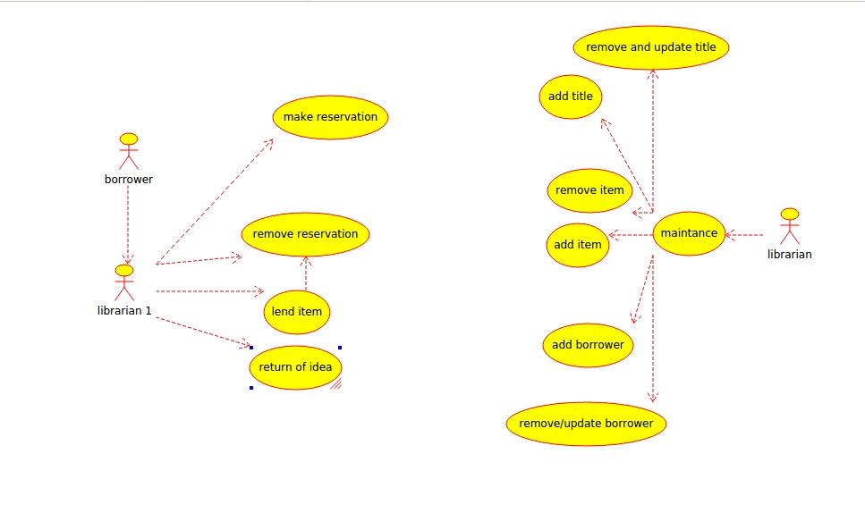

Class diagram for library management system

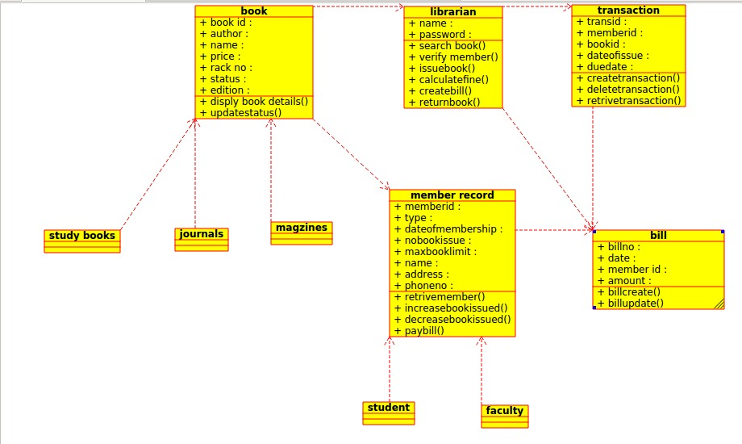

Code

/**

* Class librarian

*/

public class librarian {

//

// Fields

//

public void name;

public void password;

//

// Constructors

//

public librarian () { };

//

// Methods

//

//

// Accessor methods

//

/**

* Set the value of name

* @param newVar the new value of name

*/

public void setName (void newVar) {

name = newVar;

}

/**

* Get the value of name

* @return the value of name

*/

public void getName () {

return name;

}

/**

* Set the value of password

* @param newVar the new value of password

*/

public void setPassword (void newVar) {

password = newVar;

}

/**

* Get the value of password

* @return the value of password

*/

public void getPassword () {

return password;

}

//

// Other methods

//

/**

*/

public void search_book()

{

}

/**

*/

public void verify_member()

{

}

/**

*/

public void issue_book()

{

}

/**

*/

public void calculate_fine()

{

}

/**

*/

public void create_bill()

{

}

/**

*/

public void return_book()

{

}

}

Activity diagram for library management system

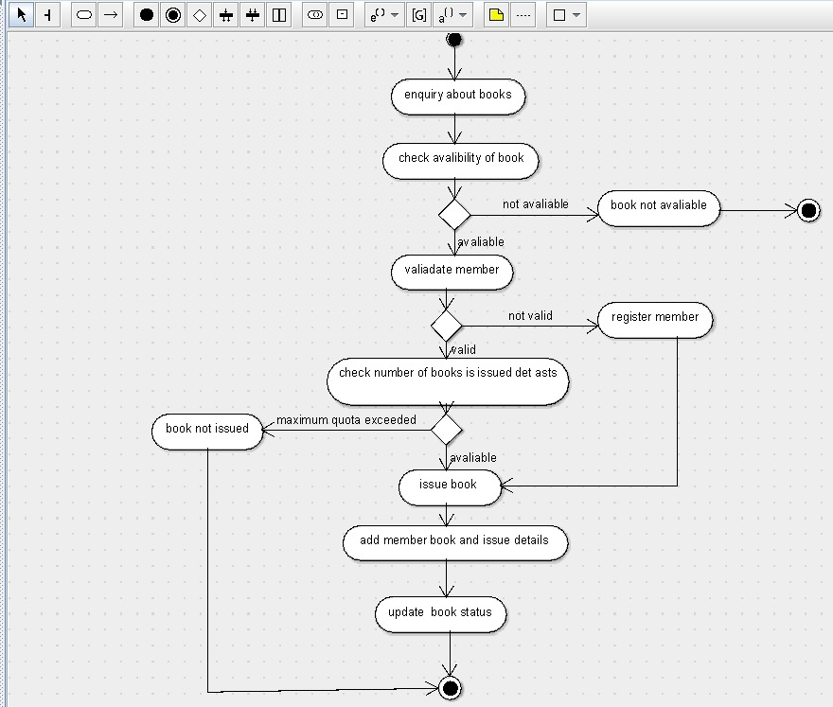

Deployment diagram for library management system

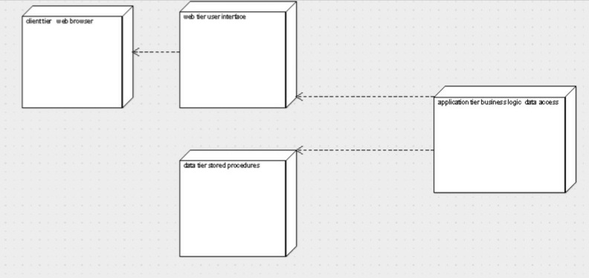

Component diagram for library management system

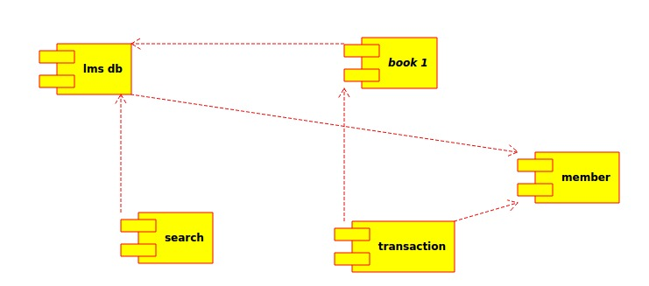

Sequence diagram for library management system

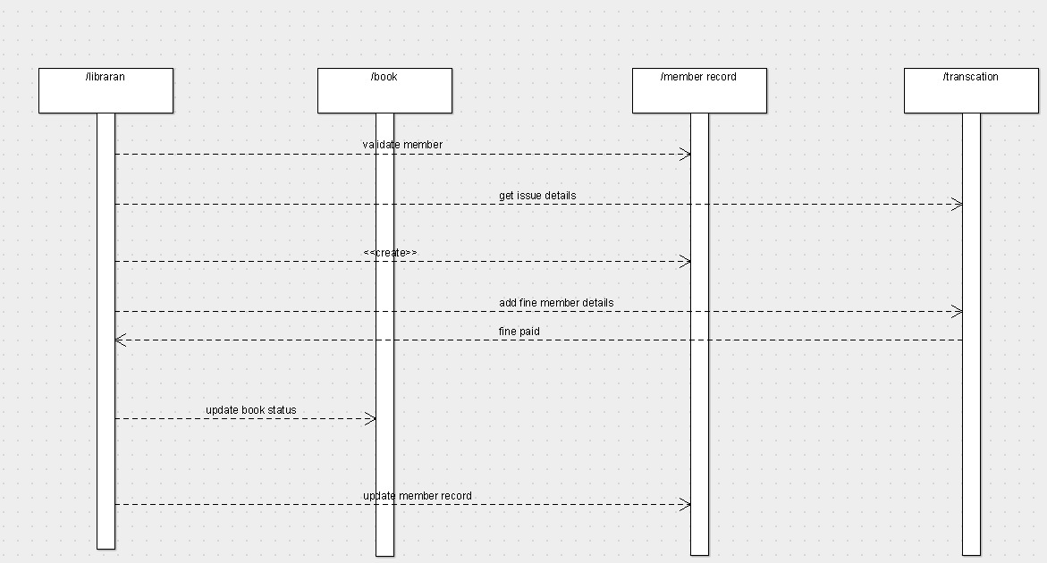

State chart for library management system

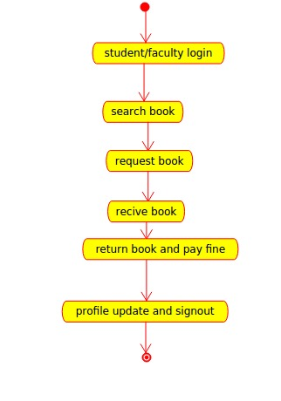

Collabration diagram for library management system

